**PostgreSQL Assignment-1**

- Create Postgres DB in the local machine and create some tables. feed some dummy data

- Prepare query file to create table, view, and create constraints on a parent and child table

- Prepare query to Join on parent and child tables.

-- Creating a database : Assignment1

CREATE DATABASE Assignment1

WITH

OWNER = postgres

ENCODING = 'UTF8'

CONNECTION LIMIT = -1

IS_TEMPLATE = False;

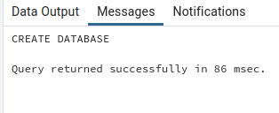

-- Creating table 1 : trainee

CREATE TABLE trainee(

trainee_id SERIAL PRIMARY KEY,

trainee_name VARCHAR(150),

trainee_stack VARCHAR(150)

);

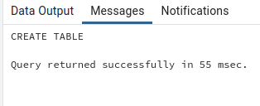

-- inserting data into : trainee table

INSERT INTO trainee

(trainee_name,trainee_stack)

VALUES

('Diwakar','java'),

('Kamran','React'),

('Hemaxi','PHP'),

('Laxmi','Blockchain'),

('Gowtham','Blockchain');

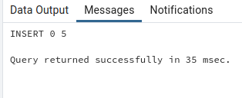

-- Viewing all data of : trainee table

SELECT * FROM trainee;

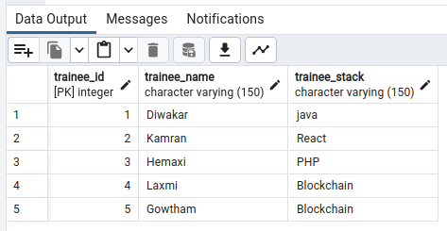

-- Creating table : course

CREATE TABLE course(

course_id SERIAL PRIMARY KEY,

course_name VARCHAR(150),

course_fee BIGINT

);

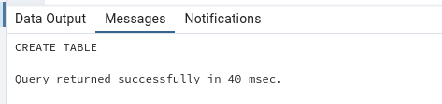

-- INSERT INTO : course table

INSERT INTO course

(course_name,course_fee)

VALUES

('JAVA',12000),

('HTML',5000),

('CSS',6000),

('Java Script',8000),

('Spring Boot',15000),

('Hibernate',10000),

('Unit Testing',12000),

('React',50000),

('MEAN',40000),

('IOT',30000);

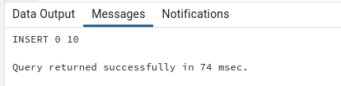

-- VIEWING ALL DATA : course table

SELECT * FROM course;

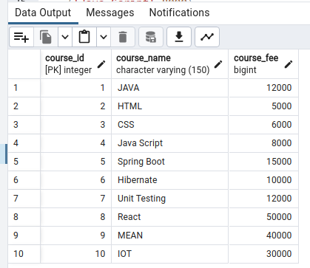

-- CREATING TABLE : student table

CREATE TABLE student(

student_id SERIAL PRIMARY KEY,

student_name VARCHAR(150) NOT NULL,

student_age INT NOT NULL,

student_email VARCHAR(150) UNIQUE,

student_course_id INT,

FOREIGN KEY(student_course_id) REFERENCES course(course_id)

);

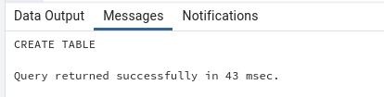

-- INSERTING DATA : student table

INSERT INTO student

(student_name,student_age,student_email,student_course_id)

VALUES

('Diwakar Kumar',23,'diwakar@gmail.com',5),

('Hinal Pachori',22,'hinal@gmail.com',1),

('Nimit Mandaviya',23,'nimit@gmail.com',6),

('Shruti Pandey',25,'shruti@gmail.com',7),

('Shailesh Darji',23,'shailesh@gmail.com',7),

('Arpit Panchal',21,'arpit@gmail.com',6),

('Parth Solanki',22,'parth@gmail.com',6),

('Yash Tailor',26,'yash@gmail.com',1),

('Hardeek Bhatia',23,'hardeek@gmail.com',1),

('Likita [Rai',22,'likita@gmail.com',5](mailto:Rai',22,'likita@gmail.com',5));



-- VIEWING DATA : student table

SELECT * FROM student;

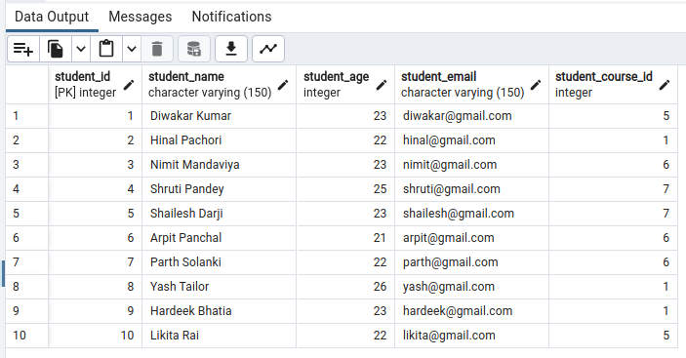

-- CREATING A VIEW : student table

CREATE OR REPLACE VIEW v_student_name AS

SELECT

student_name

FROM student;

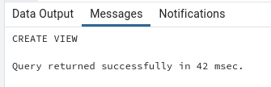

-- VIEWING DATA FROM : v_student_name VIEW

SELECT * FROM v_student_name;

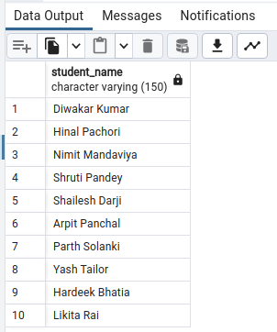

-- PERFORMING INNER JOIN : on student & course table

SELECT

s.student_id,

s.student_name,

s.student_email,

c.course_name as "assigned_course",

c.course_fee as "course_fee"

FROM student s

INNER JOIN course c ON c.course_id = s.student_course_id;

